YEAR 12 PHYSICS

SEMESTER TWO EXAMINATION 2002

Name: _________________________

Teacher: _______________________

TIME ALLOWED FOR THIS PAPER

Reading time before commencing work: Ten minutes
Working time for paper: Three hours

MATERIAL REQUIRED/RECOMMENDED FOR THIS PAPER

TO BE PROVIDED BY THE SUPERVISOR

This Question/Answer Booklet
Physics Formulae and Constants Sheet
Sheet of standard graph paper

TO BE PROVIDED BY THE CANDIDATE

Standard Items: Pens, pencil, eraser, correction fluid and ruler

Special Items: Drawing instruments, templates and calculators satisfying the conditions set by the Curriculum Council.

IMPORTANT NOTE TO CANDIDATES

No other items may be taken into the examination room.

It is your responsibility to ensure that you do not have any unauthorised notes or other items of a non-personal nature in the examination room. If you have any unauthorised material with you hand it to the supervisor BEFORE reading any further.

STRUCTURE OF PAPER

Section | No. of questions | No. of questions to be attempted | No. of marks out of 200 | Proportion of examination total
A: Short Answers | 15 | ALL | 60 | 30%
B: Problem Solving | 7 | ALL | 100 | 50%
C: Comprehension and Interpretation | 2 | ALL | 40 | 20%

INSTRUCTIONS TO CANDIDATES

Write your answers in the spaces provided beneath each question. The value of each question (out of 200) is shown following each question.

The Physics Data Sheet must also be submitted with your exam.

Calculators satisfying the conditions set by the Curriculum Council may be used to evaluate numerical answers.

Answers to questions involving calculations should be evaluated and given in decimal form. Quote the final answer to no more than four significant figures. Despite an incorrect final result, credit may be obtained for method and working, provided these are clearly and legibly set out.

Questions containing specific instructions to show working should be answered with a complete, logical, clear sequence of reasoning showing how the final answer was arrived at; correct answers which do not show full working will not be awarded full marks.

Questions containing the instruction estimate may give insufficient numerical data for their solution. Students should provide appropriate figures to enable an approximate solution to be obtained.

SECTION A: Short Answers

Marks Allotted: 60 marks out of total of 200 marks (30%)

Attempt ALL 15 questions in this section. Each question is worth 4 marks. Answers are to be written in the space below or next to each question.

- At a ceremony to commemorate the centenary of Federation, a cannonball was fired horizontally from a cannon at the edge of a cliff that overlooks Sydney harbour. At the moment of firing, an identical cannonball is dropped vertically from the cliff edge.
Assuming that air resistance is neglected, and the cannonballs start from the same height, which cannonball will hit the sea first? Explain.
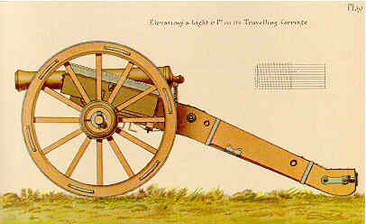
Both cannon balls will his the ground at the same time providing they are identical in all respects and if air resistance is neglected, both experience same vertical force.
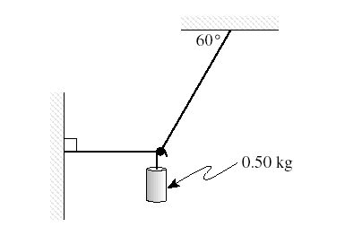
Susan sets up the apparatus below .
What would she find the tension to be in the horizontal string?
T₂ sin 30º = 4.9 N
⇒ T₂ = 9.8 N

T₁ = T₂ cos 30o

⇒ T₁ = 8.49 N
T₂
T₁
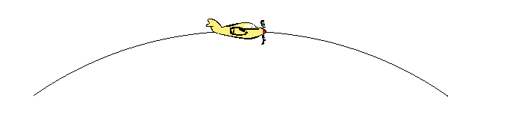
- An aircraft flies in a vertical circular path of radius 2.00 km. At the top of this path the 71.0 kg pilot feels lighter and experiences a 2.00 x 10² N upward force from the seat.
What is the velocity of his aircraft at this point?
F_{c} = W-mg
⇒ F_{c} = 496
⇒ mv²/r = 496
⇒ v = 118 ms⁻¹
W = mg = 696 N
R = 200N
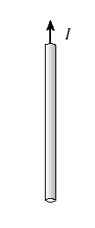
- The diagram below shows a wire carrying a current. Draw in the magnetic field associated with this wire.
A bit hard to draw on the computer, but lines should be circular, going in on the RHS and out on the LHS. More than one line should be shown, with line spacing increasing as you move further out from the wire.
- At a recent demolition in Perth, 20 sticks of dynamite were used. If one stick produces a loudness of 90 dB at 20m, what would be the loudness of the 20 sticks at 20m?
L = 10 log I/Io
⇒90 = 10 log (I/10⁻¹²)
⇒I = 0.001 Wm⁻²

I_{new} = 0.02 Wm⁻²

⇒ L 10 log (0.02/10⁻¹²)

⇒ L = 103 dB
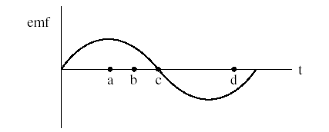
- The graph below shows how the emf produced by an ac generator varies with time. At which point in time is the rate of flux change the greatest? Explain.
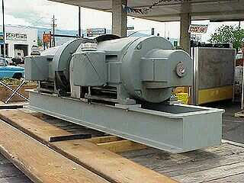
Point a. EMF is max at a since it is at this point rate of change of flux is the greatest since

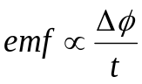

- 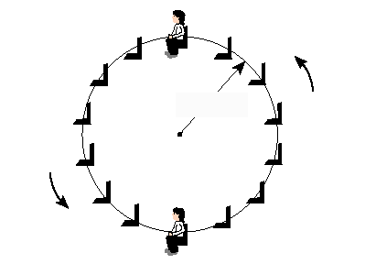Hamish, a Year 7 Physics student is riding the Ferris Wheel at the Royal Show. Making any necessary assumptions, describe how the force the seat exerts on him at the top and bottom of the ride changes
Estimate
- r = 10m
- T = 60 s
- m = 48kg

v = 2πr/T
⇒ v = 1.05 ms⁻¹

Essentially his apparent weight will vary by an amount equal to his Fc.

i.e Fc = mv²/r
⇒ Fc = 48 x 1.05²/10
⇒ Fc = 5.23 N

At top then , force is 5.23 N less and at bottom force is 5.23 more.

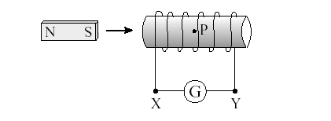
- Ellise takes a laboratory magnet and pushes it into a solenoid?
Why would you expect a current to flow through the solenoid AND in what direction would it flow?
N
As she inserts the magnetic into the solenoid, the flux in the coil changes and an emf is produced. By Lenz’s law direction is x to Y.

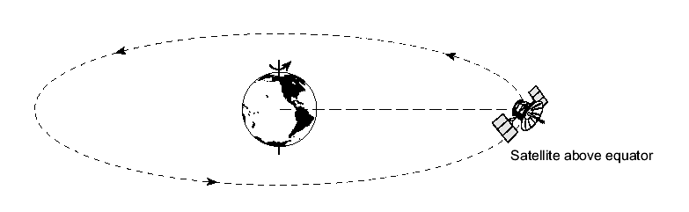
- Geostationary satellites appear to remain stationary to an observer on the Earth. Such satellites are placed in orbit far above the equator.
Explain why such satellite’s all must have the same orbital radius ?
M_{s}
M_{e}
T = 24 hrs

Now 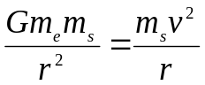
We can divide through by m_{s} and can show that all have the same r

- The movie "Apollo 13" was concerned with a space vehicle which was intended to land on the moon. In making the movie, the film producers had to simulate the apparent weightlessness that was experienced by the astronauts in the space vehicle on the way to the moon. They did this by filming inside an aeroplane which flew in a parabolic path.
Explain how weightlessness arises in the aeroplane flying in the parabolic path described above.
During parabolic flight, the pilot allows the plane to free fall so that the vertical acceleration of the aeroplane is exactly equal to the acceleration due to gravity. Thus no reaction force thus apparent weighlessness.

- Two materials, A and B, were tested and the stress versus strain graphs are shown below. The elastic limit of each material is shown as e. The fracture point is indicated as f at the end of each graph.
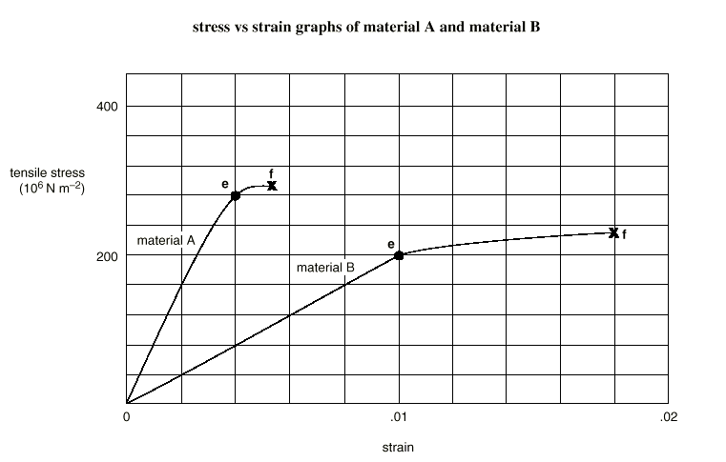 Which one of the two materials (A or B) is tougher? Support your answer with evidence from the graphs.
Toughness is related to area under the graph, thus the toughest is material B.

For full marks students should estimate the area which work done per unit volume.

For material A about 1350000 Jm⁻³
For material B about 2100000 Jm⁻³

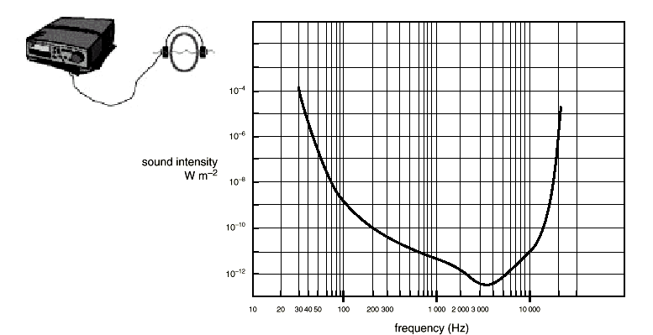
- In an experiment to determine hearing sensitivity, a student uses a set of earphones and a signal generator. For a range of frequencies, he determines the sound intensity (measured at the ear) at which the sound just becomes inaudible. The diagram below shows the sensitivity of hearing of the student.
What range of frequencies can the student hear if the sound intensity at the student’s ear is 1.0 × 10⁻¹¹ W m⁻²?

Everything from 600 – 10000 Hz
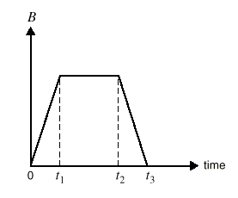
- The on-off action of a lightning stroke produces an electromagnetic field surrounding the stroke. It is this field that causes the crackling in your radio or TV during a thunderstorm. The magnetic field, B, produced by a lightning stroke varies with time as shown below.
A small coil is placed perpendicular to the magnetic field, and the induced emf is monitored on an oscilloscope. Sketch a graph that shows the variation of the induced emf with time?

- A fan that ventilates an underground mine is run by a very large d.c. electric motor. This motor is connected in series with a variable resistor to protect the windings in the coil. When the motor is starting up, the variable resistor is adjusted to have a large resistance. The resistance is then lowered slowly as the motor increases to its operating speed. Explain why no resistance is required when the motor is running at high speed, but a substantial resistance is needed when the motor is starting up.
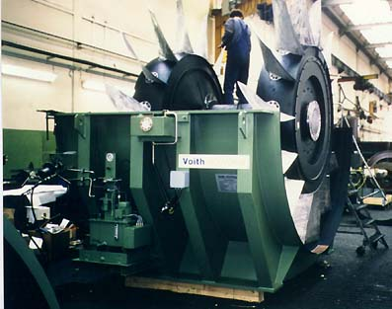
When starting up, very little of the electrical energy is converted to kinetic. Once going it is not a problem.

When too much electrical energy , it is dissipated as heat in the windings and they can burn out.
- An organ is constructed so that it has open pipes. A note produced by one of these pipes has a frequency of 280 Hz. The length of this pipe is 1·2 m. A representation of a standing wave corresponding to this note is shown.

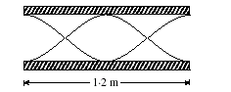
Represented lines

What do the lines that are drawn in the diagram actually represent?
Represent the maximum displacement envelope of the air particles

- Explain how a washing machine shown below is able to remove water from clothes when it is spin drying?
As drum spins, it provides a force on the sock, the sock is accelerated towards the centre. The holes in the drum allow the water to continue in its straight line path (1st Law) but precludes the passage of the sock.

Don’t pay “ the water is flung or forced out’
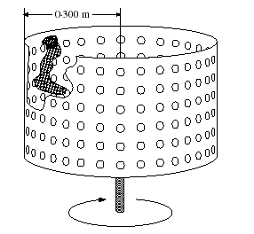

QUESTIONS CONTINUE ON THE NEXT PAGE

SECTION B: Problem Solving

Marks Allotted: 100 marks out of total of 200 marks (50%)

This section contains 7 questions, two of which contain a choice. You should answer
ALL of the questions.

Answer all questions in the spaces provided.

- [14 marks]
Tom is caught on a banked roundabout in East Perth. He is travelling at a steady speed and his situation is shown in the plan and side views below. The car’s speed is such that there is no sideways frictional force between the tryes and the road.
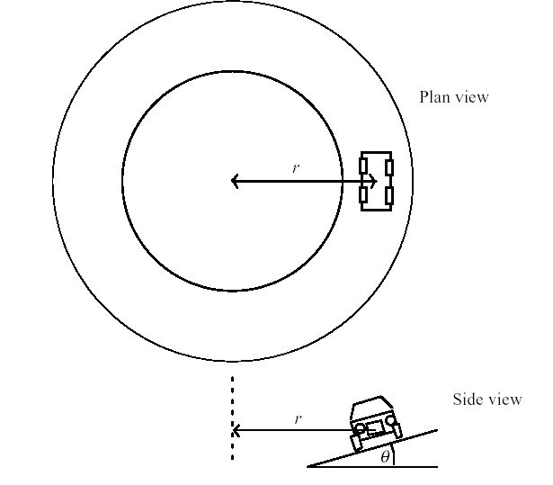
  - Does Toms’ car have an acceleration? Explain your answer. [2 marks]
Yes it has acceleration because its velocity direction is changing ✓ toward the
centre of the track. ✓
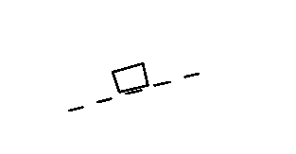
  - We could represent Toms’ car on the roundabout by a block in the diagram below
On the diagram above, draw and label all the forces acting on the moving car?
[3 marks]
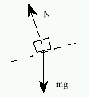
✓ for weight downward, ✓✓ for normal force perpendicular to track.
Subtract marks for non-existent or wrong forces.)
  - Is there a resultant force acing on the car? Explain [2 marks]
Yes, there is a resultant force: the car is not in equilibrium, but accelerating toward
the centre of the circular road. ✓ The resultant force on it is toward the centre,
and in the force diagram it would be the resultant of the two forces shown. ✓
  - Why is it than engineers when designing roundabouts and freeway off ramps, often bank them?
[2 marks]
So that reaction force has a horizontal component to provide centripetal force. This, when combined with frictional forces enable cars to travel at a higher speed ✓✓
  - Using any necessary assumptions, calculate the speed that the car must travel at in order for there to be no sideways frictional force between the tyres and the road?
[3 marks]
Assume 1. Banked 17º, radius 30 m ✓

Vertically there is equilibrium: [1] N cosθ = mg
Horizontally there is a net force and acceleration:
Net force = N sinθ ✓
⇒ 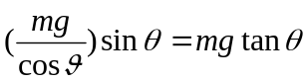

⇒ mgtanθ = mv²/r

⇒ v = 9.6 ms⁻¹ ✓
  - Suppose now that some oil had been spilled on the roundabout. What effect would this have on Toms’ car if he maintained the speed you calculated in part e)? Explain.
[2 marks]
Little or none.✓ All necessary centripetal force is being provided by the horizontal component of the reaction force. ✓
- [17 marks]
Over the past year or so astronomers have discovered many planets orbiting distant stars. In July this year some Australian astronomers also made a discovery in HD117462. Some of these recent discoveries are shown in the diagram below. In the diagram, M_{JUP} refers to the mass of Jupiter ( 1.90 x 10²⁷ kg). An astronomical unit is the earth- sun distance.
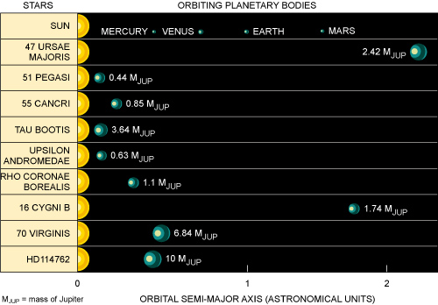
The following data gives the planetary orbital period ‘T’ as a function of distance ‘r’ from the central star 16 Cygni B. Only the first three of several data sets are shown.
The relationship between the data shown above can be summarised by:
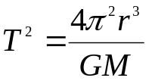
Period, T  (x 10⁵ s) | Radius, r  (x 10⁹ m) | Period² , T²  (x 10¹⁰ s) | Radius, r³  (x 10³⁰ m)
2.43 | 10.0 | 5.9 | 1.0
4.47 | 15.0 | 20 | 3.38
6.91 | 20.0 | 47.7 | 8.0

  - If necessary, modify the data above so that you can draw a straight line graph that relates period to orbital radius. If necessary, use the blank columns in the table above to insert your modified data. Explain what you have done.
[5 marks]
thus 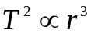. So a graph of T² against r³ will yield a straight line with gradient 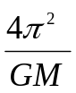✓✓✓

Table ✓✓
  - 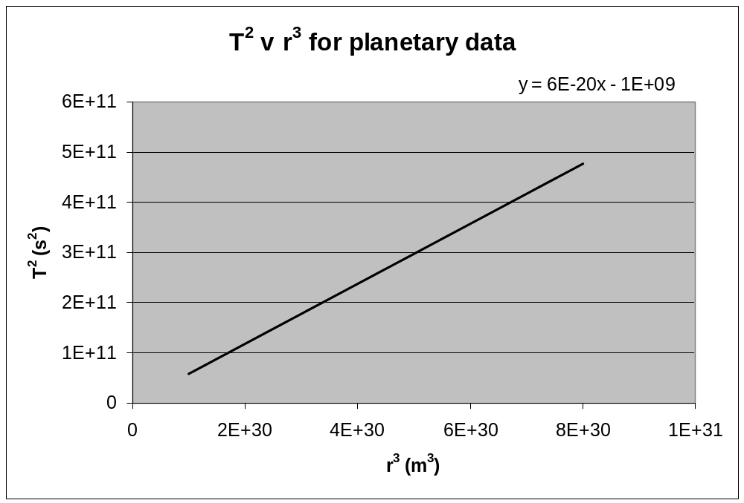Plot your modified data on the graph paper below OR write the equation that relates the variables on the graph paper.
[4 marks]
Equation is T² = 6.0 x 10⁻²⁰ r³ – 1.0 x 10⁻⁹ ✓✓✓✓
  - Using the graph, determine the mass of the central star 16 Cygni B?
[4 marks]
Gradient of graph = 6.00 x 10⁻²⁰ ✓

m = ✓

⇒ M = 4π²/6.00 x 10⁻²⁰ x 6.67 x 10⁻¹¹

⇒ M = 9. 85 x 10³⁰ kg ✓✓

  - What would you estimate the acceleration due to gravity to be on the planet orbiting 16 Cygni B? List any assumptions that you make.
[4 marks]
Assume:
- M = 1.74 M_{jup}
⇒ M = 1.74 x 1.90 x 10²⁷
⇒ M = 3.306 x 10²⁷ Kg✓
- r = 1.74 x r_{jup}
⇒ r = 1.74 x 7.18 x 10⁷
⇒ r = 1.25 x 10⁸ m✓

g = GM/r²

⇒ g = (6.67 x 10⁻¹¹ x 3.306 x 10²⁷)/ (1.25 x 10⁸)²
⇒ g = 14.1 ms⁻² ✓✓

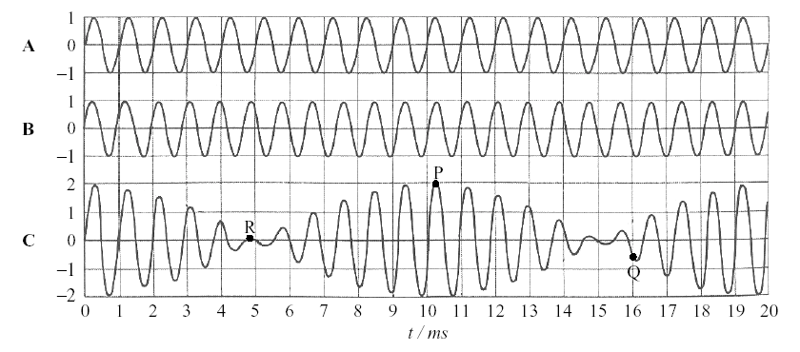
- [16 marks]
Two tuning forks A and B of slightly different frequencies are sounded simultaneously, producing two sound waves of the same amplitude. The figure below shows the disturbance at a particular point in the air as a function of time for each of the tuning forks separately, and the resultant disturbance C.
Three points on the resultant waveform are labelled P, Q and R. For each of these points, check whether the resultant waveform C as drawn is correct, by referring to the two component waves. Explain in each case.
  - Point P
[2 marks]
Yes ✓Both displacements maximum in same direction hence resultant is double✓
  - Point Q
[2 marks]
Yes ✓Vector sum OK (may estimate magnitudes).✓
  - Point R
[2 marks]
Yes ✓Displacements equal and opposite hence cancel to give zero.✓
  - Use the diagram to determine
    - the frequencies of A and B;
[2 marks]
A: From graph, period is 1 ms so frequency is 1000 Hz. ✓
B: From graph, period is 0.9 ms so frequency is 1100 Hz. ✓
    - the beat frequency.
[2 marks]
Beat frequency: A maximum intensity every 10 ms so beat frequency is
100 Hz.✓✓
  - Beats at this frequency could not actually be perceived as beats by human hearing. Explain why.
[2 marks]
This beat frequency is too high✓ to be perceived✓ as loudness variations.
  - In order that the beats become perceived as such by the ear, would the difference in frequency between A and B have to be greater or smaller than in the case above? Explain.
[2 marks]
Frequency difference must be smaller in order to decrease the beat frequency.✓✓
  - Explain how use could be made of beats to tune a guitar string against a tuning fork.
[2 marks]
Sound string and fork together and listen for beats. ✓
Tune so that beats get slower, meaning string is getting closer to fork frequency. ✓
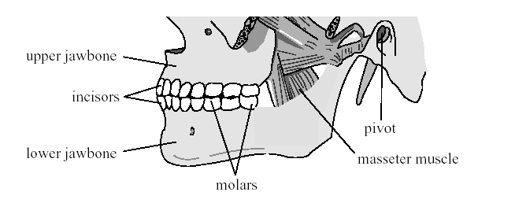
- [11 marks]
The diagram below shows the position of a person’s jawbones. The lower jawbone pivots at one end. The muscle that makes it move is called the masseter muscle.
During biting, the lower jawbone can be represented by the simplified model shown below. It has a horizontal part 7.0 cm in length and a part at a angle from the horizontal, which is 4.0 cm long. The force from the masseter muscle is vertical at the junction of the two parts. Assume the weight of the lower jawbone is negligible.
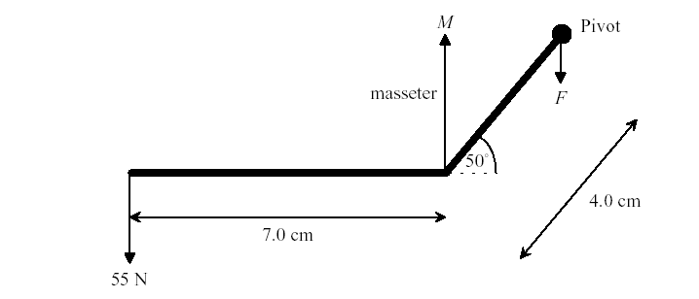
During biting, there is a 55N force on the incisors at the front of the lower jawbone.

  - Calculate the magnitude of M, the force applied by the masseter muscle
[4 marks]
Correct application of the principle of moments ✓
M 4cos50 = 55 +x (7+4cos50)

(Award this mark if a student attempts a correct application of the principle
of moments, but is unable to calculate the perpendicular distance from M to
the pivot.)

⇒ M = 205 N✓✓
  - Calculate the magnitude of F, the force at the pivot.
[3 marks]
Resultant force overall is zero ✓
i.e. 55 + F= M

⇒ F = 150 N✓✓
  - Explain why more force can be provided at the molars, during chewing, than at the incisors.
[4 marks]

Realisation that the molars are nearer to the pivot.✓✓
F and r are inversely proportional , smaller r thus larger F ✓✓
(Award no marks for answers in terms of pressure and/or the area of the top of the
tooth.)
- 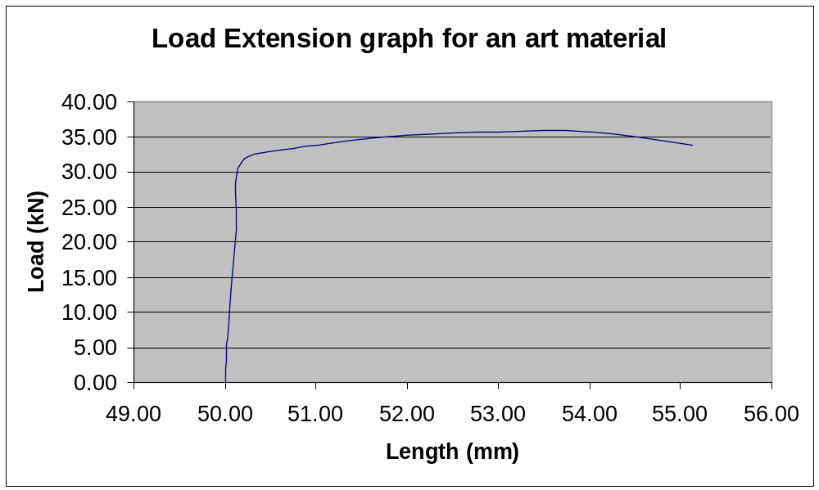[16 marks]
An artist uses some material to support part of a project. The force extension graph of a sample of the material is shown below.
ΔF
Δl
  - Given that material is circular in cross section and has a radius of 3 .00 mm, determine the Young’s Modulus of the material? [5 marks]
From graph 21 mm = 1 mm
⇒ 3 mm = 0.14 mm

Δl = 0.14mm✓

Σ = 0.14/50
⇒ Σ =\ 0.0029✓
ΔF = 23 kN

Δσ = 23000/π(0.003)²

= 8.13 x 10⁸ Nm⁻²✓

E = σ/Σ
⇒ E = = 8.13 x 10⁸/0.0029
⇒ E = 2.8 x 10¹¹ Pa✓

  - Estimate the force that must be applied to store 50.0 J of strain energy in the material?
[2 marks]

Approx area of graph . Assume rectangle ✓
Thus 50 = 35000 x Δ l
⇒ Δ l
= 1.43 mm which equates from the graph to about 33 kN✓

  - What material would you expect the wire to made from? Explain.
[2 marks]
Relate calculate value of E to data sheet✓. Probably steel ✓
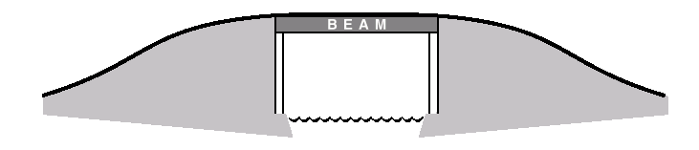
  - Cast-iron beams were once used in bridges to support a roadway as shown below.
Engineers carefully selected the cross-section of bridge beams. They took into consideration
- the forces acting on the beam
- the least mass the beam could have without reducing safety
- the fact that cast iron is stronger under compression than under tension.
Diagrams A–D represent possible cross-sections of the beam. Which one of the following cross-sections would an engineer select as most appropriate for the cast-iron beam? Give reasons for your answer.

[2 marks]
A✓ plus suitable reason ✓ (relatively little metal , top section narrow as top is in compression and bottom under tension ✓
  - Consider a simple beam bridge made of cast iron, that needs to span a river 6.0 m wide. If the beam has a mass of 850 kg and you stand 2.0 m from one end, what would you estimate to be the vertical forces that the ground needs to exert on the ends of the bridge. List any assumptions that you make?
[3 marks]
Assume your weight 867 N✓
8340 N 867 N
Fa
Fb
About A

ΣCM = ΣACM
⇒ 867 x 4 + 8340 x 3 = Fb x 6
⇒ Fb = 4750 N✓

Fa + 4750 = 867 + 8340
⇒ Fa = 4457 N✓
  - There are some problems in using stone for this type of construction in the same way that the cast iron. Explain how an engineer could span this river using stone and why this particular design is chosen?
[2 marks]
Any suitable explanation involving arches Diagram ✓ , plus an explanation along the lines of all stone is in compression, which is good as stone is strong in compression but weak in tension. ✓
- [14 marks]
Max and Michelle are buying loudspeakers for their hi-fi. They are choosing between two models, a 35-cm diameter speaker (P), and a 5-cm one (Q). Both speakers operate equally well over the complete audible frequency range. Max is standing in front of the speakers, and Michelle is the same distance away, but to one side, as shown below.
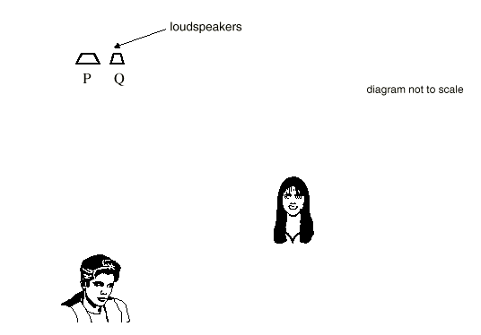
As a test of the speakers they play sounds of 10 000 Hz and 200 Hz, and compare the intensity that they each hear.

  - The wavelength of sound of frequency 200 Hz is 1.65 m. What is the wavelength of sound of frequency 10 000 Hz?
[2 marks]
λ = v/f
⇒ λ = 331/10000
⇒ λ = .033 m✓✓

Max comments that the intensity of the sound of both frequencies seems the same from either speaker. However Michelle says that for the larger speaker, the 10 000-Hz sound is significantly softer than the low frequency sound.
  - In the space below, explain these observations. Include relevant calculations and/or diagrams to support your reasoning.
[4 marks]

Low frequencies diffract more etc ✓

Any suitable diagram and /or calculation ✓✓✓
In the end, they decided to buy two of the 5cm model. When they got them home, instead of listening to Ja Rule and dancing, they decided to try out an experiment. They connected the speakers to the same output on the CD player, placed the speakers 12.0 m apart and put on their single frequency CD (ie a CD that produces sound of a single frequency)
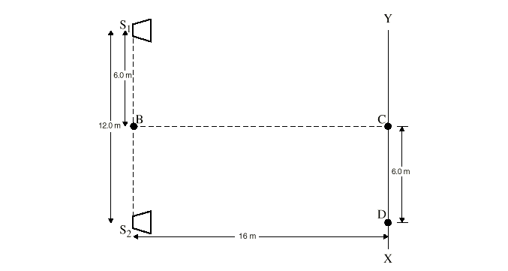
  - What happens to the sound intensity as Michelle walks from point C to point B? Explain your answer
[2 marks]
Hears a loud sound as she is walking an antinodal line✓✓
Michelle now walks from point C towards X. She detects maxima and minima in the sound intensity. At the point D she detects the second minimum after leaving point C.

  - What is the wavelength of the sound produced by the loudspeakers? Show your working.
[4 marks]
Path difference = 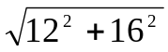-16
⇒ pd = 4m ✓
⇒ 3 x λ/2 = 4 ( 3 since second minima)
⇒ λ = 2.67 m ✓✓✓

  - Max notices that some of the decorative plates that are on his desk begin to vibrate? Explain this observation
[2 marks]

Resonance or forced vibration ✓, explanation ✓
- [12 marks]
The diagram below shows some of the energy levels inside a mercury atom.
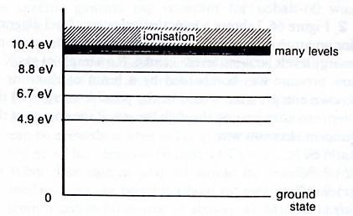
  - How many lines would you expect this atom to show in its
    - Absorption spectrum [2 marks]
4
    - Emission spectrum [2 marks]
.
10
    - Determine the frequency of one of the lines in the emission spectra
[2 marks]
4.90 ev → 0✓

⇒ E = 4.9 ev
⇒ E = 7.84 x 10⁻¹⁹ J

E = hf
⇒ f = E/h
⇒ f = 7.84 x 10⁻¹⁹ /6.63 x 10⁻³⁰

⇒ f = 1.18 x 10¹⁵ Hz✓

  - Suppose a beam of electrons of energy 9.9 eV pass through mercury vapour, what could be the possible energies of the emerging electrons?
[3 marks]
9.9 eV, 5.0 eV, 3.2 eV, 1.1 eV, 0.1 eV✓✓✓
  - What actually happens to the energy the electrons lose? Be specific and support your answer with a calculation.
[3 marks]
SECTION C: Comprehension and Interpretation.
Energy is transferred to ground state electrons in the mercury, exciting them to higher levels. Eg if the ground state electron is promoted to 3rd level, it gains 8.8 eV, therefore original retains 1.1 eV✓✓✓

This section contains 2 questions and is worth 20% (40 marks out of 200) of the marks for the examination. Answer both questions in this section.

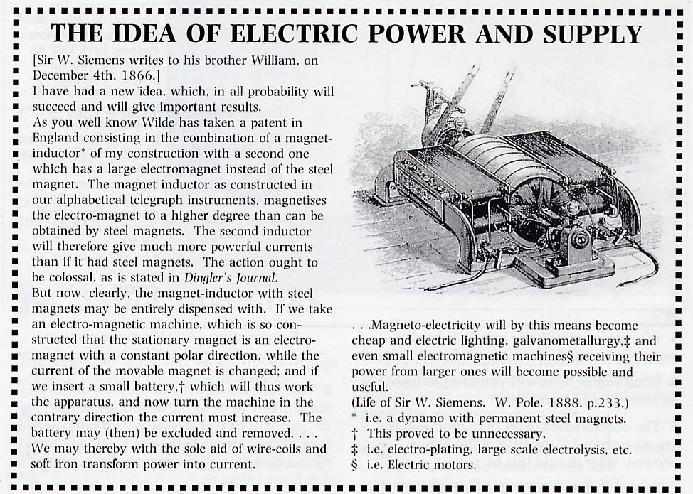
  - Describe the generator that Siemans is proposing?
[3 marks]
Stator (stationary magnet) is an electromagnet, needs battery to establish original magnetic field( Indeed, this is the case with Western Power, “cold” dynamo starts need a small external generator to excite the stator windings)✓✓✓
  - Why do you think that the battery can be removed once the machine is moving? Explain
[2 marks]
In the generator, mechanical energy is being changed to electrical energy.✓ There is no need for an extra injection of electrical energy in the first place✓✓

Can accept

It is not, it can be removed when generator is producing its own current
  - What advantages did Siemens see for society with the development of his generator?
[3 marks]
- Provision of cheap electric lighting✓
- Galvometallurgy✓
- Small electromagnetic machines✓
  - Why is the soft iron considered to be more effective than the steel?
[2 marks]
The soft iron is magnetised to a greater degree ✓ than the steel, producing a stronger field✓
  - How could Siemans have increased the emf produced?
[3 marks]
- Faster rotation
- Greater coil area
- larger number of coils
- Stronger magnetic field (any 3 one mark each)
  - When does Siemens’ generator produced its maximum emf? Explain
[3 marks]
When the coil is parallel to the field, the rate of change of flux is the greatest, thus so is the emf ✓✓✓ OR by looking at the diagram , there are multiple armature coils, so a near constant emf is produced
  - To deliver power from generators used today, high voltages are used. Explain why high voltages are used and how the voltage changes occur?
[4 marks]
High voltages are used so as to reduce transmission losses across the transmission wires✓. These voltage changes are accomplished by the use of transformers ✓

Some detail on transformer construction (✓)
Mention that ac is used✓
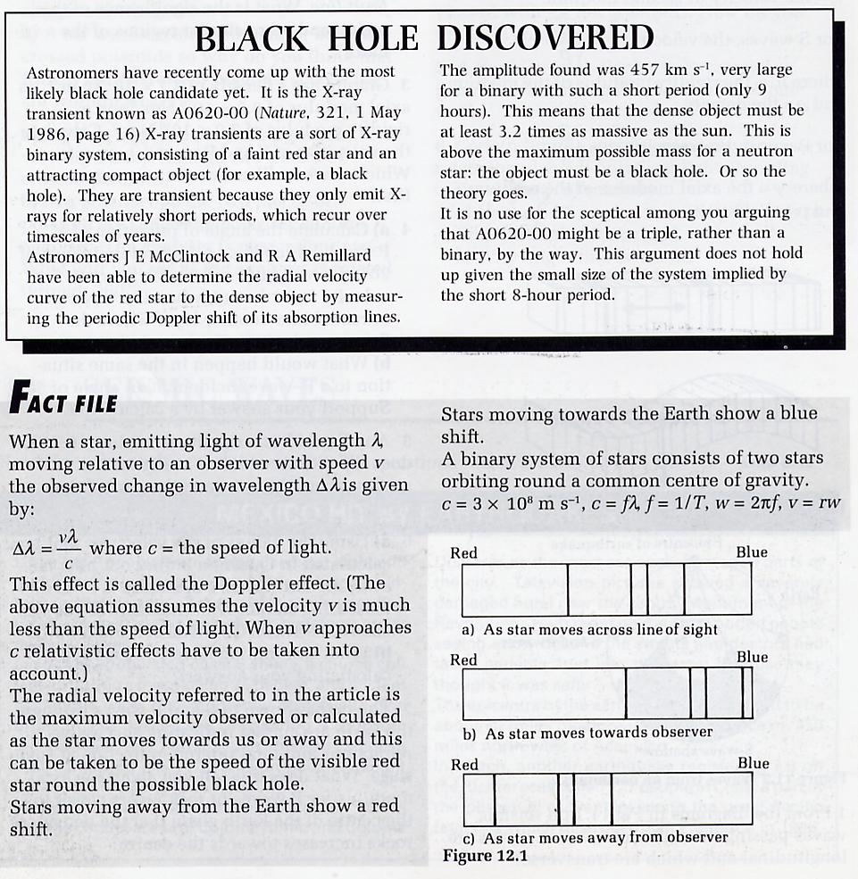
  - Given that stars moving towards the earth show a blue shift, what would you expect to happen to the wavelengths of X-rays from an X-ray transient star as it is moving away from an observer?
[4 marks]
We would expect the wavelength to get larger✓✓✓✓

Red shift ie may shift towards the visible spectrum
  - If the X-ray transient star emits X-rays of frequency 10¹⁹ Hz, calculate the wavelength of the X-rays emitted?
[3 marks]
v = f x λ
⇒ 3.0 x 10⁸ = 1.0 x 10¹⁹ x λ
⇒ λ = 3.0 x 10⁻¹¹ m ✓✓✓
  - Determine the change in wavelength as the star moves towards or away from an observer? (Use the maximum amplitude of the radial velocity)
[4 marks]

V = 4. 57 x 10⁵ ms⁻¹
⇒ Δλ = 4. 57 x 10⁵ /10¹⁹

⇒ Δλ = 4.57 x 10⁻¹⁴ m ✓✓✓✓
  - The spectrum of a star has characteristic dark lines across it? What is the origin of these dark absorption lines?
[4 marks]
These are due to the absorption of light at certain frequencies by gases in the stars’ atmosphere. This light is then emitted in all directions leading to a reduction in the light travelling towards the observer from the star. The frequencies are determined by the elements in the stars atmosphere. Each element has a characteristic pattern. If the pattern observed is at frequencies greater than or less than expected, the star is moving towards or away from the observer. ✓✓✓✓
  - During a total eclipse of the sun, the dark absorption lines of our sun become bright emission lines. Why does this happen?
[3 marks]
The observer sees the bright emission spectra due to the elements in the suns atmosphere which give lines at exactly the same frequencies✓✓✓
  - Astronomers have been hunting black holes for a number of years, but not that many have been found. What do you think are the main properties of black holes that makes the search so difficult?
[2 marks]
Small ✓ and dark ✓
END OF EXAM

